Instructions to Authors Preparing Their

Camera Ready Papers for SJEEE Journal

First Author1, Second Author2, Third Author3

*1Final year EEE, Saranathan college of Engineering, Panchapur, Trichy -12*

*2 Second year EEE, Saranathan college of Engineering, Panchapur, Trichy -12*

*contact.author@mailserver.com*

*[1]Abstract*—These instructions provide basic guidelines to help authors prepare their final camera-ready papers for submission to Students Journal of Electrical and Electronics Engineering. The abstract, with a maximum of 200 words, should be self-explanatory and summarize the essential qualities of the paper. The abstract must clearly state the novelty of the work regarding the journal fields. Do not use more than 200 words in the abstract and also try to use only English characters in the abstract. Other characters, like special symbols, Greek alphabet letters, subscript and superscript styles, could not be included in the abstract. Do not cite references in the abstract. Do not delete the character immediately before the Abstract; it sets the footnote at the bottom of this column. Before starting a new submission you are kindly invited to read all the information.

*Keywords -* five key words or phrases arranged alphabetically and separated by commas.

# Introduction

Prospective authors are invited to submit papers that fit within the scope of the journal. Papers should be written in English and submitted in final camera-ready form. All text has to be edited by using the styles defined in this document.

It is mandatory to submit your original work in Microsoft Word format (.DOC or .DOCX) by using our mail-id. Your paper length should not exceed by 6 pages.

# Paper and Text Format

When you open this document, select “Page Layout” from the “View” menu in the menu bar (View | Page Layout), which allows you to see the footnotes. Then type over sections or cut and paste from another document and then use markup styles. Do not change the font sizes or line spacing to squeeze more text into a limited number of pages. Use italics for emphasis; do not underline.

To insert images in Word, position the cursor at the insertion point and either use Insert | Picture | From File or copy the image to the Windows clipboard and then Edit | Paste Special | Picture (with “Float over text” unchecked).

You are kindly advised to use this template for editing your submission, as you have nothing to change in terms of paper and text format. Simply applying the styles defined here will be sufficient.

Author name, affiliation and complete address are to be placed underneath the title. In case of multiple authorship of a submitted paper, the affiliation and complete address of each author must be specified.

# Tables, Figures, Equations

Illustrations and tables should be progressively numbered, following the order cited in the text; they may be organized in one or two columns. Tables must be accompanied by a caption placed at the top. Figures (abbreviated Figure X in the caption and Fig. X in the text) must be accompanied by a caption placed underneath ("Figure Caption" style). References made to tables in text will not be abbreviated e.g. “in Table 1, TN Roman means Times New Roman”.

TABLE 1. THE RECOMMENDED FONTS

|  |  |  |  |
| --- | --- | --- | --- |
| **Item** | **Font** | **Size** | **Style** |
| Title of paper | TNRoman | 24 | Norm |
| Authors' names | TNRoman | 11 | Norm |
| Authors' address | TNRoman | 11 | Italic |
| Abstract | TNRoman | 9 | Bold |
| Title of sections | TNRoman | 10 | Norm |
| Text, Formulae | TNRoman | 10 | Norm |
| Algorithms | Courier New | 10 | Norm |
| References | TNRoman | 8 | Norm |

When inserting figures, they should be as clear as possible. Do not use font sizes smaller than 8 TNRoman, as they will be difficult to read.

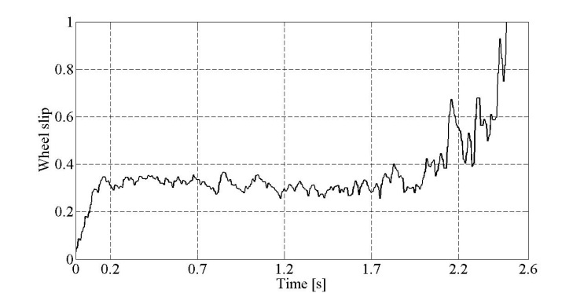 Figure 1. Wheel slip response with the proposed control algorithm

Color pictures are also acceptable, but you have to be sure they will be also visible on grayscale printing. In the online version of your paper they will be in color version.

# Math

If you are using Word, use either the Microsoft Equation Editor or the MathType add-on (http://www.mathtype.com) for equations in your paper (Insert | Object | Create New | Microsoft Equation or MathType Equation). “Float over text” should not be selected.

 (1)

Each formula should occupy one line. Consecutive numbers should be marked in brackets. All equations should be numbered (the numbers should be right-aligned), and cited (1) in the text.

# References Section

Number the citations consecutively, in square brackets [1]. The sentence punctuation follows the brackets [2]. Multiple references [1], [2] and [3], should be cited [1-3]. Also, use [4],[6-8] and not [4],[6],[7],[8]. In sentences, refer simply to the reference number, as in [3]. Do not use “Ref. [3]” or “reference [3]” except at the beginning of a sentence: “Reference [3] shows ....”.

Give all authors’ names; do not use “et al.” unless there are six authors or more. Use a space after authors’ initials. Papers that have not been published should be cited only if they have a DOI number assigned and should be referenced as “to be published” [4]. Papers that have been submitted for publication or have been accepted for publication - but not yet specified for an issue and they have no DOI assigned, should not be cited.

# Conclusion

A conclusion section is compulsory. Although a conclusion may review the main points of the paper, do not replicate the abstract as the conclusion. A conclusion might elaborate on the importance of the work or suggest applications and extensions. Make sure that the whole text of your paper observes the textual arrangement on this page.

References

1. J. U. Duncombe, “Infrared navigation Part I: An assessment of feasibility (Periodical style),” IEEE Trans. Electron Devices, vol. ED-11, pp. 3439, Jan. 1959. [Online]. Available: http://dx.doi.org/10.4316/ieee.1959.3422
2. M. Young, *The Technical Writers Handbook.* Mill Valley, CA: University Science, pp. 1023-1045, 1989.
3. D. Knuth. The Art of Programming. Addison-Wesley, pp. 82-86, 1973.
4. E. H. Miller, “A note on reflector arrays (Periodical style—Accepted for publication),” *IEEE Trans. Antennas Propagat.*, doi: 10.4316/ieee.1959.3422, to be published.
5. S. P. Binguac, “On the compatibility of adaptive controllers (Published Conference Proceedings style),” in *Proc. 4th Annu. Allerton Conf. Circuits and Systems Theory*, New York, 1994, pp. 8–16. [Online]. Available: http://dx.doi.org/10.1011/sp.1994.

1.